60004210210

Amartya Mishra

COMPS – C31

ML Experiment 2

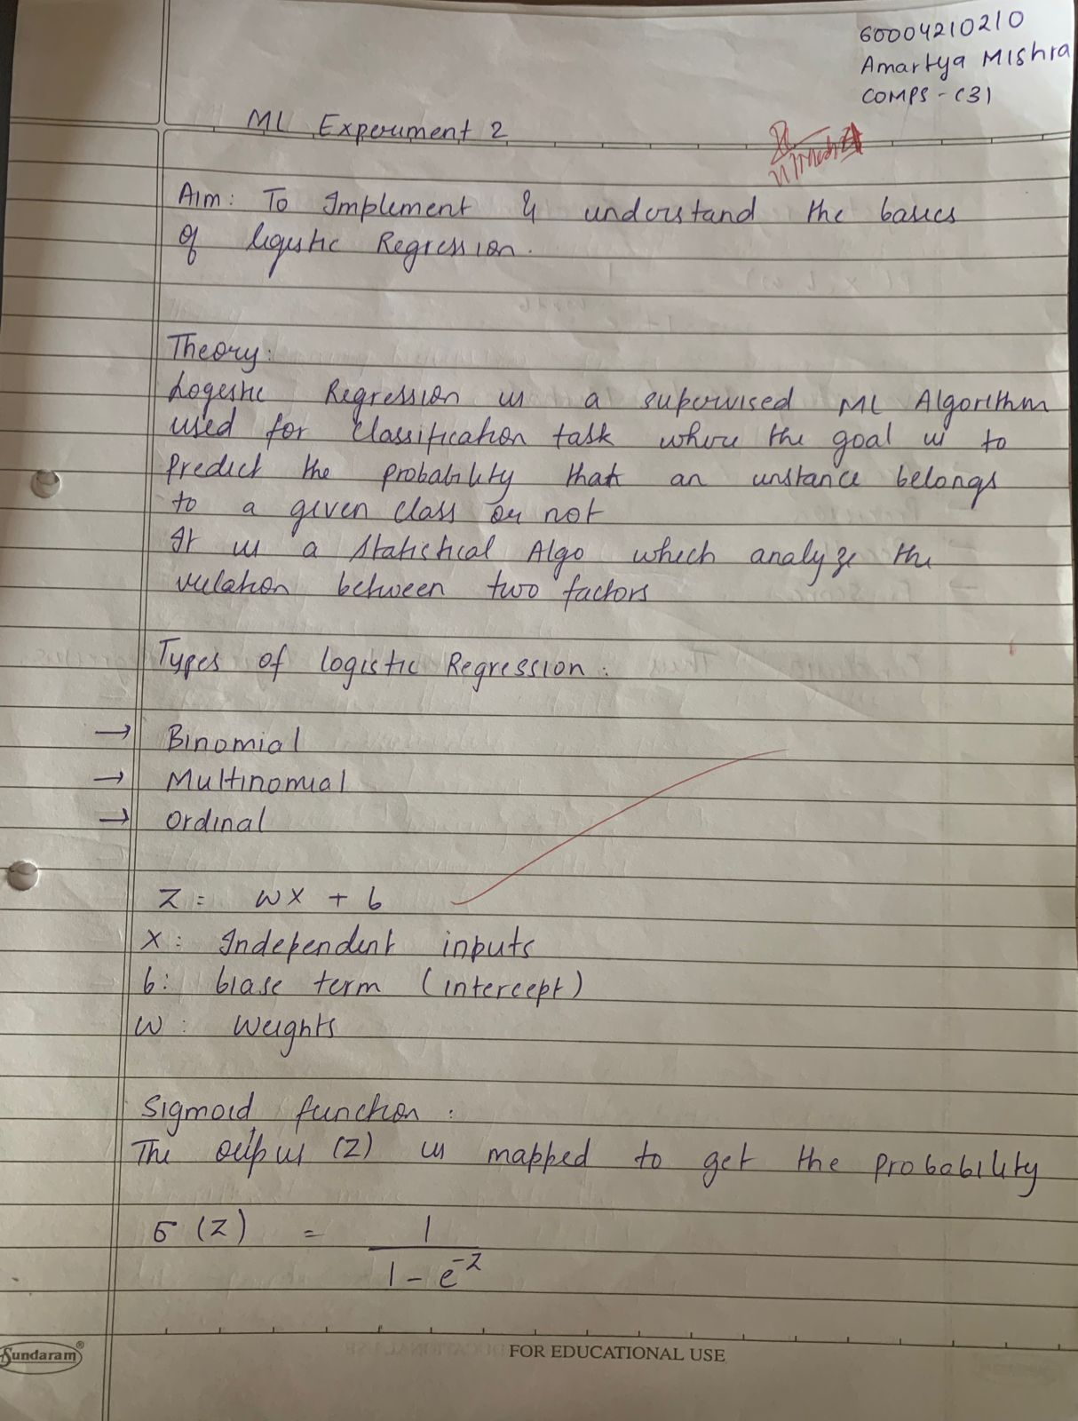

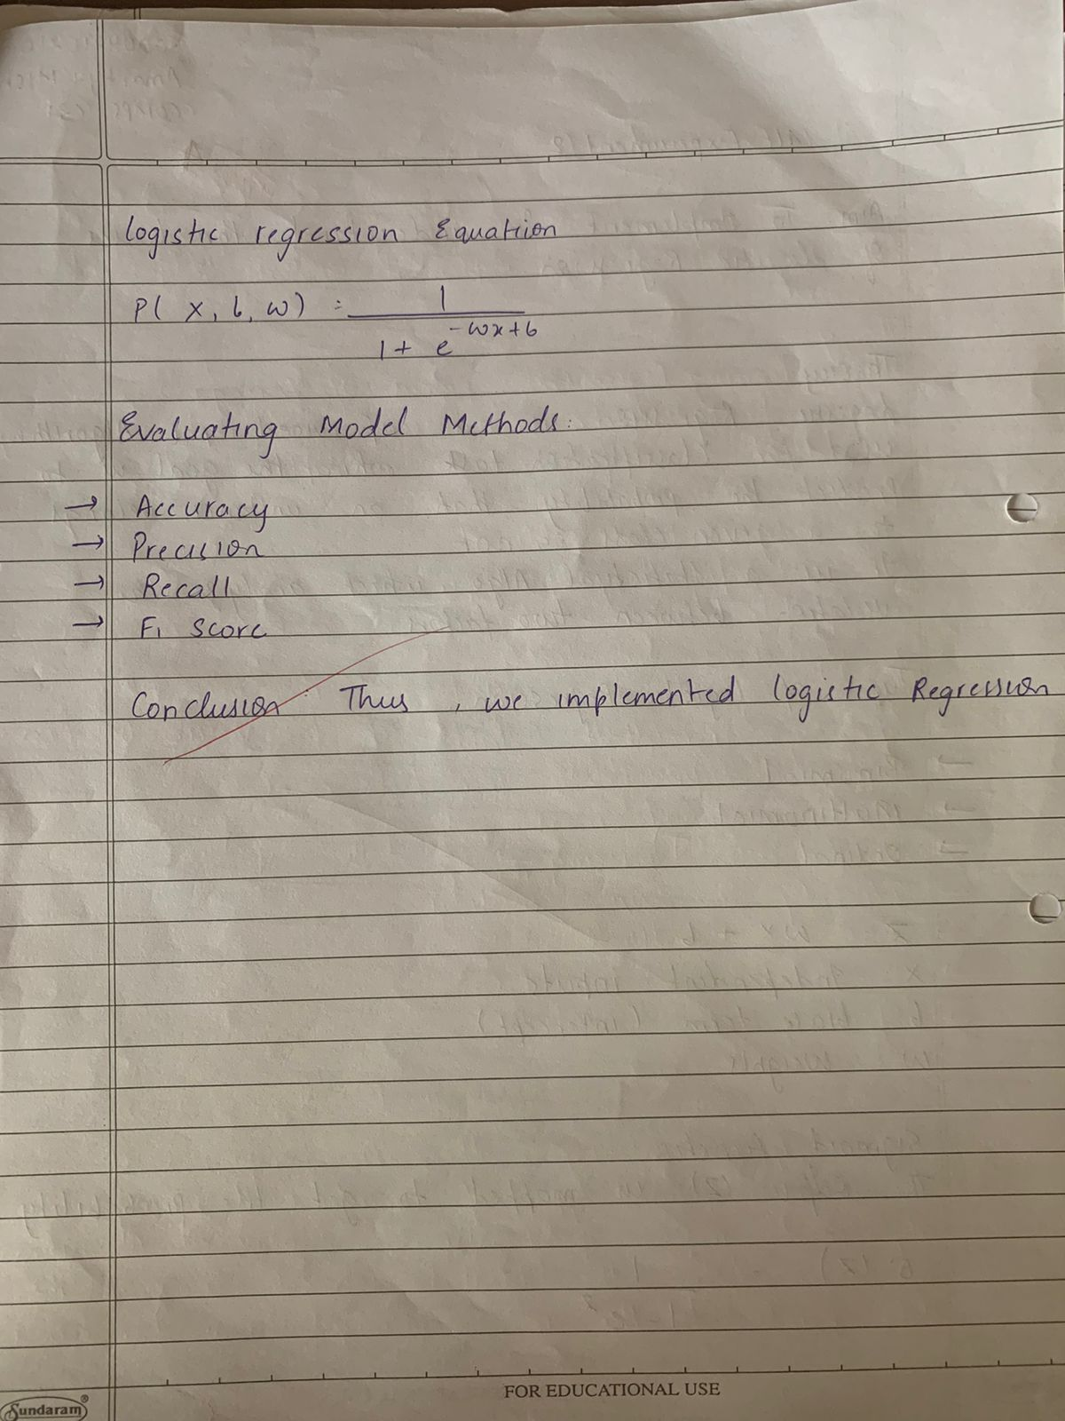

**Implementation:**

